Question : what is file operation in linux operating system?

Answer:

Linux file operation refer to how Linux-based computers organise, store and track system files. The file operation is basically a combination of directories or folders that serve as a placeholder for addresses of other files.

Question: what are implementations of file operation of linux operating system?

Answer:

Grep commands:

**tecmint@TecMint ~ $** grep "aaronkilik" /etc/passwd

**aaronkilik:x:1001:1001::/home/aaronkilik:**

**tecmint@TecMint ~ $** cat /etc/passwd | grep "aronkilik"

**aaronkilik:x:1001:1001::/home/aaronkilik:**

tail commands:

**tecmint@TecMint ~ $** **tail -n 5 /var/log/auth.log**

Jan 6 13:01:27 TecMint sshd[1269]: Server listening on 0.0.0.0 port 22.

Jan 6 13:01:27 TecMint sshd[1269]: Server listening on :: port 22.

Jan 6 13:01:27 TecMint sshd[1269]: Received SIGHUP; restarting.

Jan 6 13:01:27 TecMint sshd[1269]: Server listening on 0.0.0.0 port 22.

Sort commands:

**tecmint@TecMint ~ $** **sort domains.list**

linuxsay.com

linuxsay.com

news.tecmint.com

tr commands:

**tecmint@TecMint ~ $** **echo "WWW.TECMINT.COM" | tr [:upper:] [:lower:]**

www.tecmint.com

**tecmint@TecMint ~ $** **echo "news.tecmint.com" | tr [:lower:] [:upper:]**

NEWS.TECMINT.COM

Question: what is file permission of linux operating system?

Answer:

Linux is a multi-user operating system, so it has security to prevent people from accessing each other’s confidential files.

Question: what are the implementations of file permissions in linux operating system?

Answer:

Chmod u+x command:

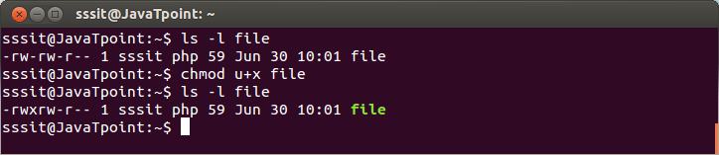

Chmod g-x and u-w commands:

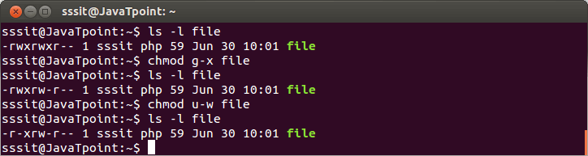

Chmod a+w command:

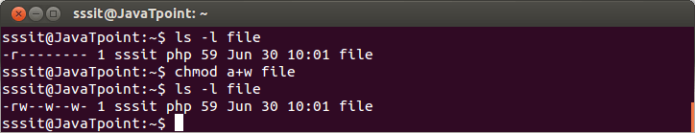

Chmod +w file command:

